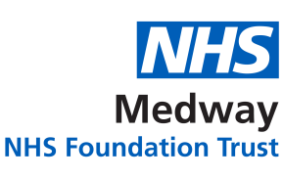
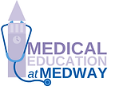
Doctors in Training
Induction Dates 2024

Medway NHS Foundation Trust Inductions 2024
Date | Venue & Type | Speciality
Wednesday 07 February 2024 | Medical Education Centre - TBC | CST, Anaesthetics / ICU, ACCS
Monday 04 March 2024 | Medical Education Centre - TBC | Paediatrics ST3
Wednesday 03 April 2024 | Medical Education Centre - TBC
W/C Monday 29 July 2024 (TBC) | Medical Education Centre - TBC | FY1
Wednesday 07 August 2024 | Medical Education Centre - TBC | All Specialities – FY2s, GPSTs, Cores & Highers
Monday 02 September 2024 | Medical Education Centre - TBC | Paediatrics & Gastroenterology ST3
Wednesday 02 October 2024 | Medical Education Centre - TBC | All Specialities ST3+

Abbreviations
FY1: Foundation Year 1 | FY2: Foundation Year 2 | GPST: General practice Speciality Trainee
ST: Speciality Trainee | ACCS: Acute Common Stem Trainee | IMT: Internal Medical Trainee
CST: Core Surgical Trainee

