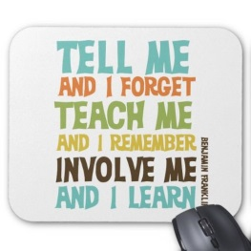
Gemma Wrighton, Clinical Simulation Manager, Daniella James, Medical Undergraduate Education Facilitator and
Dr Manisha Shah, Clinical Lead for Simulation
Background
Medway NHS Foundation Trust has provided dedicated clinical skills and simulation since 2014 for medical students.
- 2014 Simulation Year 5 Medical Students (Medical Student simulation lead appointed)
- 2015 1 hour skills sessions for Year 5 Medical Students and simulation (Clinical skills practitioner appointed)
- 2016 1 hour skills sessions for Years 4 & 5; Simulation and Basic surgical skills Year 5; Basic Surgical Skill EMCC Year 4
This allowed the students access to basic skills sessions and always received positive feedback. The majority of feedback that we received was for more simulation based education (SBE); especially from the Year 4 medical students who were not receiving any.
As a growing department we decided to review processes to ensure effective use of student’s time away from clinical setting, use of clinical skills facilitators’ time and more importantly, to allow an advanced learning environment for the students. This new process allowed us to focus on experiential learning whilst building in capacity to introduce spiral learning over the two years to increase complexity of the same subject being taught whilst reemphasising the old knowledge. (Jarome Bruner (1960)).
Students at Medical School are provided with knowledge and skills, this then needs to be translated into real life working on a busy ward with challenging patients in a time limited fashion. Our teaching programme is designed to provide concrete experience of real life by participation in scenarios. Reflective observation is provided by watching scenarios and debriefing, we also incorporate hands on skills that are competency tested.
Research
What is the best process for adult development?
‘Learning is the process whereby knowledge is created through the transformation of experience’ (Kolb, 2014)
Experiential Learning Theory (ELT) provides a holistic model of the learning process and is a multi-linear model of adult development, both of which are consistent with what we know about how we naturally learn, grow, and develop. The theory is called "Experiential learning" to emphasize the central role that experience plays in the learning process.
Experiential learning theory differs from cognitive and behavioural theories in that cognitive theories emphasize the role of mental processes while behavioural theories ignore the possible role of subjective experience in the learning process. The experiential theory proposed by Kolb takes a more holistic approach and emphasizes how experiences, including cognitions, environmental factors, and emotions, influence the learning process.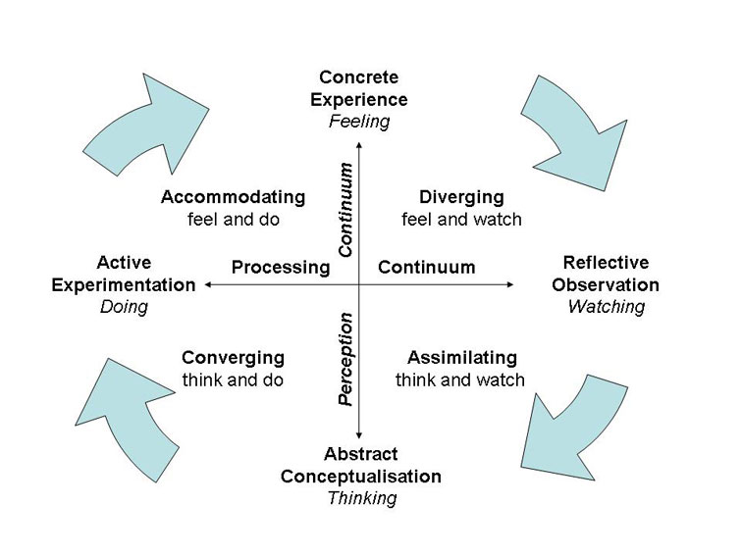

Feedback:
“Fantastic! Great knowledge & clearly communicated, instilled confidence in us.”
“Clear teaching, great scenarios. Good to put things into reality.”
“Session was amazing!!! Wish we could do more.”
Outcome
After revising the approach to students learning environment. We stripped back the learning environment and process and started afresh focusing on some key factors:
- Capturing Feedback – revising data captured, QR coding functionality and reporting
- Structure of the experiential learning cycle
- Active Experimentation (Wwow Course)

- Structure

- 2018: Implementation of new simulation timetable (Clinical simulation Manager appointed)
- Year 4: Simulation session, Clinical skills block session, Aseptic Technique & Basic Suturing LEARN
- Year 5: Simulation session, Human Factors, Clinical skills block session & Basic surgical skills REVISION
- TTF1: Implementation of Wwow Simulation and skills PRACTICE

- Feedback
We would like structured feedback to provide evidence as to the value of SBE and clinical skills. This quest for evidence led us to design:
- Pre-placement questionnaire based on confidence and competence
- Post-placement questionnaire addressing confidence and competence post simulation and skills QR Code
- Post teaching questionnaire to identify areas in need of improvement

References:
Bruner, J.S. (1960). “The Process of education. Cambridge, Mass.: Harvard University Press”
Kolb, D.A. (2014). “Experiential Learning: Experience as the Source of Learning and Development”, p.51, FT Press

